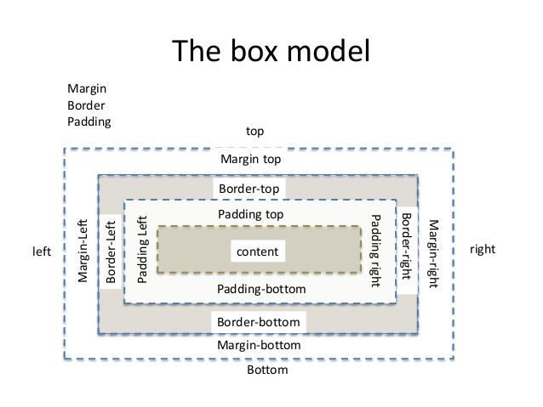

Definition and Usage
The margin shorthand property sets all the margin properties in one declaration. This property can have from one to four values.
Examples:
- margin:10px 5px 15px 20px;
  - top margin is 10px
  - right margin is 5px
  - bottom margin is 15px
  - left margin is 20px

- margin:10px 5px 15px;
  - top margin is 10px
  - right and left margins are 5px
  - bottom margin is 15px

- margin:10px 5px;
  - top and bottom margins are 10px
  - right and left margins are 5px

- margin:10px;
  - all four margins are 10px
Note: Negative values are allowed.
The padding shorthand property sets all the padding properties in one declaration. This property can have from one to four values.
Examples:
- padding:10px 5px 15px 20px;
  - top padding is 10px
  - right padding is 5px
  - bottom padding is 15px
  - left padding is 20px

- padding:10px 5px 15px;
  - top padding is 10px
  - right and left padding are 5px
  - bottom padding is 15px

- padding:10px 5px;
  - top and bottom padding are 10px
  - right and left padding are 5px

- padding:10px;
  - all four paddings are 10px
Note: Negative values are not allowed.

All CSS Dimension Properties
Property | Description
height | Sets the height of an element
max-height | Sets the maximum height of an element
max-width | Sets the maximum width of an element
min-height | Sets the minimum height of an element
min-width | Sets the minimum width of an element
width | Sets the width of an element

